Practical - 3
Practical Title: Responsive UI Design using CSS Grid, Flexbox, and Bootstrap/Tailwind
Problem Definition: Design responsive layouts for Home, About, Registration, Dashboard, and Events pages using CSS Grid and Flexbox. Optional to use CSS framework such as Bootstrap or Tailwind. Ensure mobile-first responsiveness.

Theory

1. What is Responsive Web Design?
Answer: Responsive Web Design is a technique that makes web pages adjust automatically to different screen sizes such as mobile, tablet, and desktop.

2. What is CSS Grid?
Answer: CSS Grid is a layout system used to create two-dimensional layouts with rows and columns.

3. What is Flexbox?
Answer: Flexbox is a CSS layout model used to arrange and align items efficiently in a row or column.

4. What is Bootstrap/Tailwind CSS?
Answer: Bootstrap and Tailwind CSS are CSS frameworks that provide ready-made classes to build responsive and attractive web pages quickly.

Implementation/ Output/Result
- Design the pages with HTML & CSS
- Added colors and designs
- Changed links with buttons
- Make it user friendly

Evidence of Work (Screenshots) 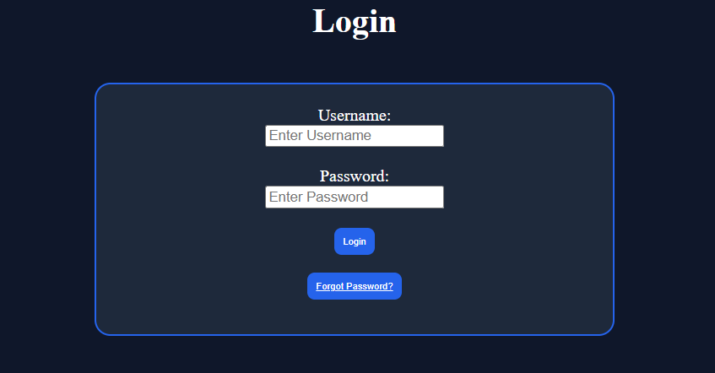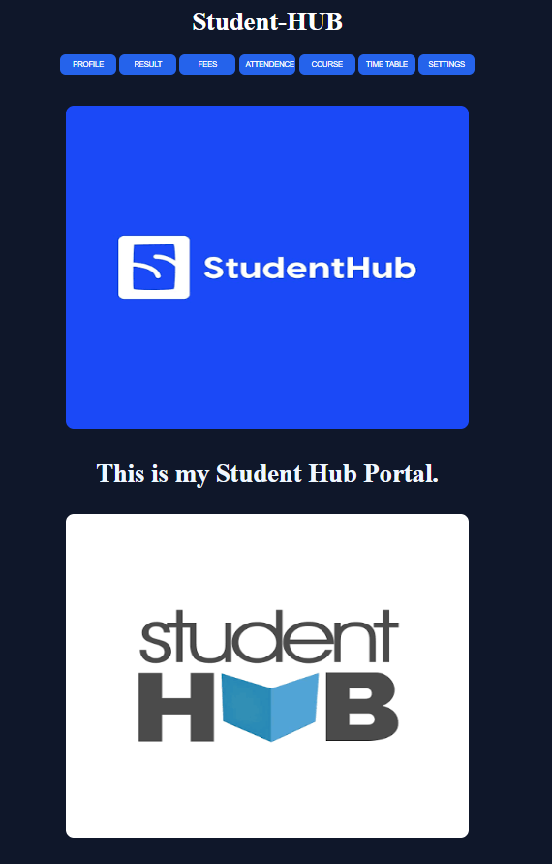
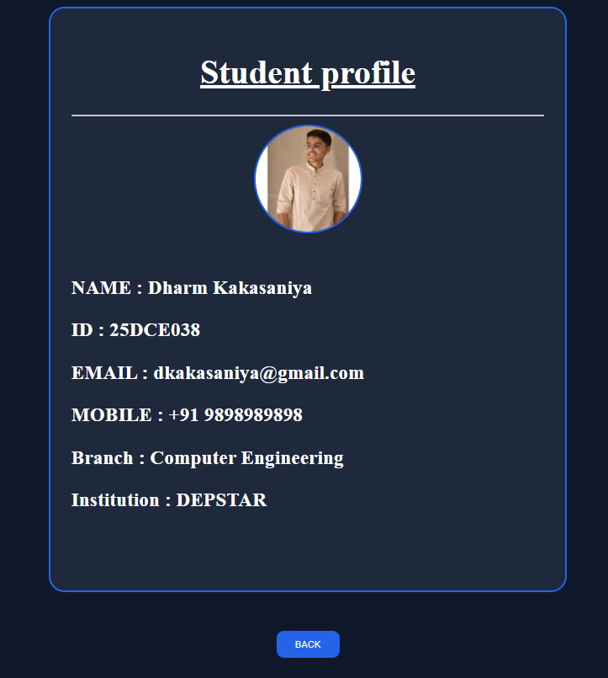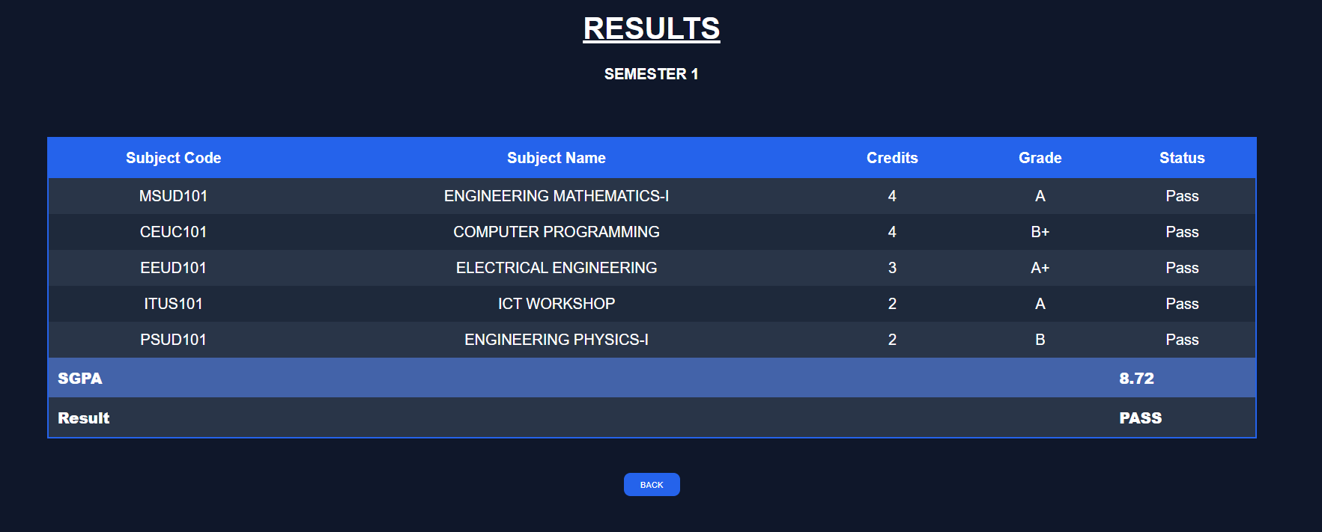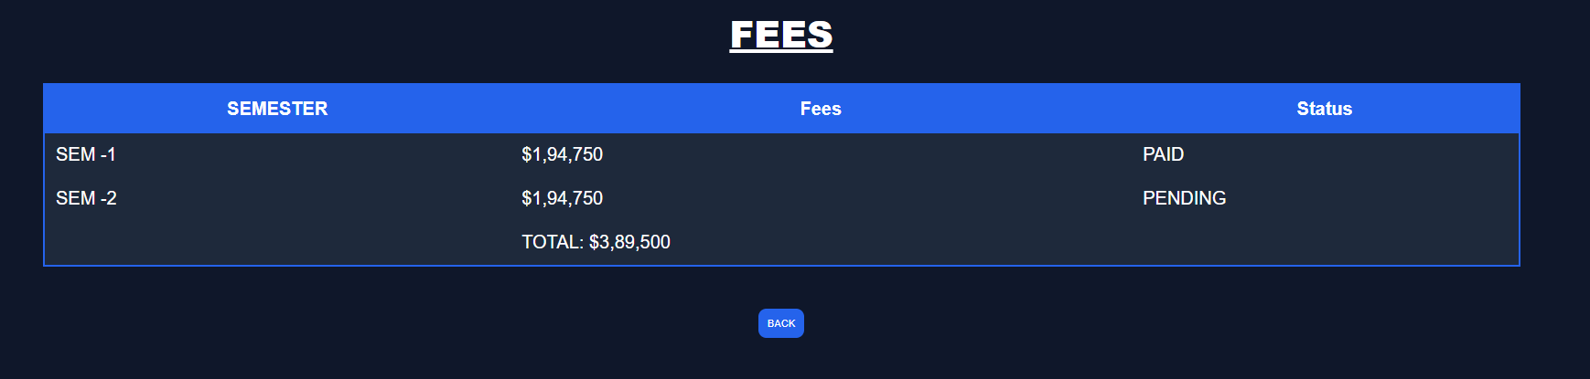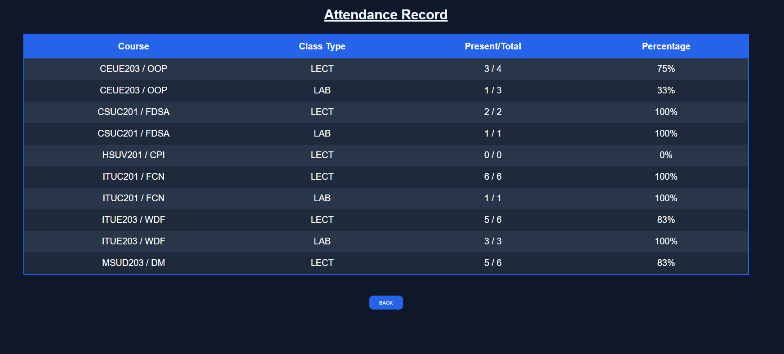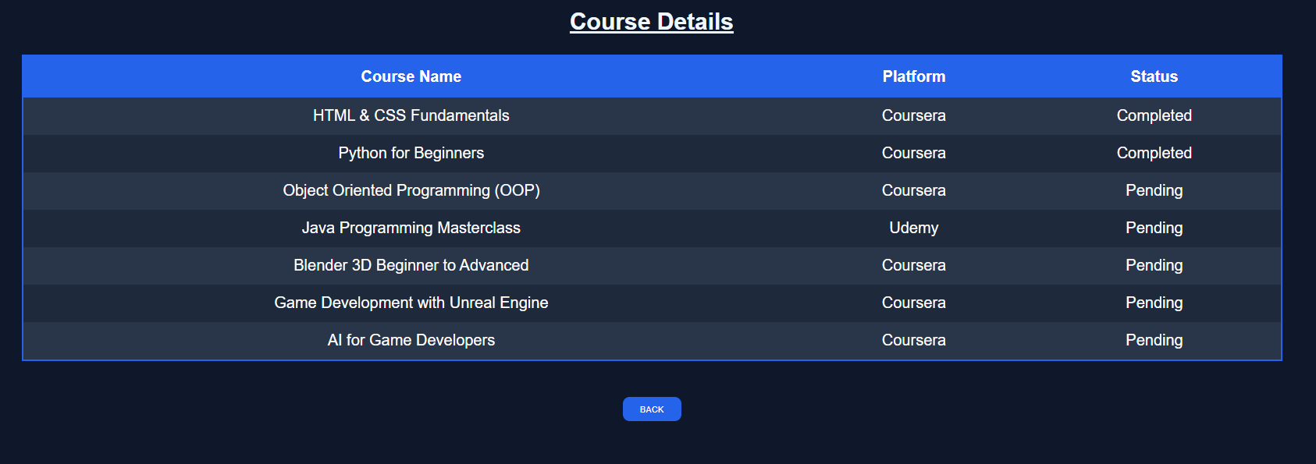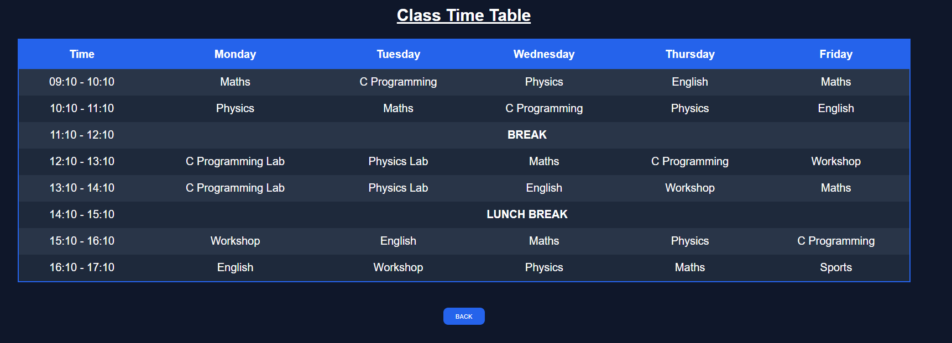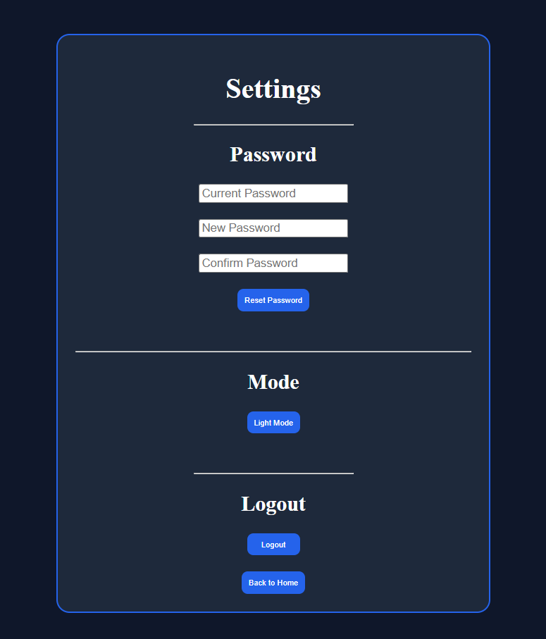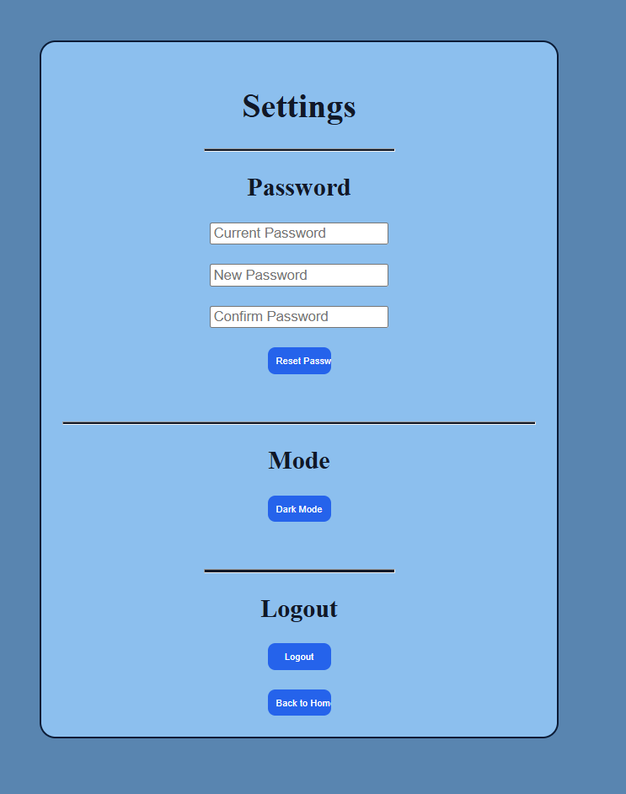
Description: This are the web pages of student hub portal with HTML and Implemented CSS.

GitHub Repository Link: https://github.com/dharmkakasaniya01/Student

Challenges Faced:
While performing this practical, I faced some difficulty in creating responsive layouts using CSS Grid and Flexbox. Initially, adjusting the design for different screen sizes and maintaining proper alignment was challenging.

Learning Outcomes:
After completing this practical, I learned how to design responsive web pages using CSS Grid and Flexbox. I also learned to create mobile-friendly layouts and use Bootstrap or Tailwind CSS to develop responsive user interfaces efficiently.

Faculty Remarks:

